VICK CEMETERY
In Livingston County, Kentucky. About 6 miles out of Burna and through Hampton near Good Hope Church at the end of Quertermous Road.
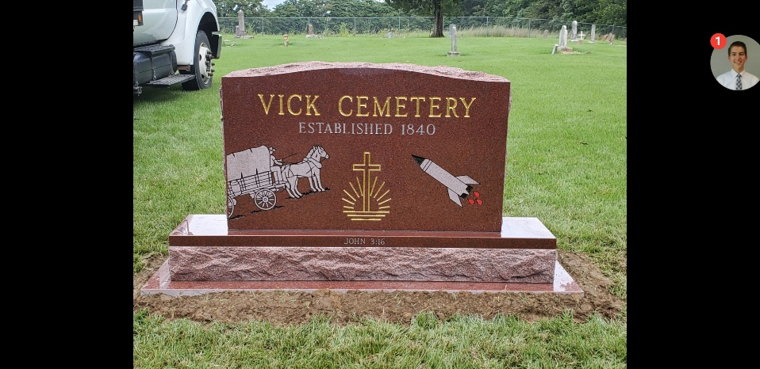
The original information was collected on June 23, 1989 by Stella & Gailen Vick and was narrated by the history that Sidney Calvin Vick remembered
On August 17, 2013, William (Billy) Sidney Vick and Gailen Vick (sons of Sidney C. Vick) recorded the following changes of new markers and changes that had been made to the cemetery.
I clean and strong six-foot-high chain-link fence was built around the cemetery and the fence rows and peripheral land was cleaned by David Clifford Vick before the burial of his wife Barbara Herndon Vick.
- Plot 571 – a new Marker for Jonthan Wesley Vick born and died 1969
- Plot 610 – Marker for Lola May Cromwell
- Plot 784 - Marker for Barbara Herndon Vick, Feb. 26, 1956-Nov. 9, 2010
- Plot 749 - Marker for David Clifford Sr Vick
- Plot 784 - Marker for Sherrill E. Vick born Jun. 2, 1945 & Nancy L. Vick born Nov. 9, 1946
- Plot785 - Marker for Melvin Charles Vick born Mar. 14, 1941, died Nov. 6, 2007
- Plot 786 - Marker for Robert Dewey Vick born Sept. 1, 1939, died Feb. 12, 1996
- Plot 799 - Marker for Wesley Norman (Pete) Vick, born Sept. 4, 1948, died Aug. 13, 2013
January 17, 1990 - The land for the Vick Cemetery, is referred to In a Deed made on April 3rd, 1964 between Jesse L. Quertermous wife, Nell M. Quertermous, Of Joy, Livingston County. Ky. And W.A. Quertermous and wife, Jeanette Quertermous, of Livingston County, Kentucky. A certain or parcel of land lying in Livingston County, Kentucky, on North side of Cumberland River, and more particularly described as follows:
Lying on the waters of Buck and Bayou Creeks, beginning at a white oak corner to P.R. Vick, running with his line N 25.5W 124 poles to a sycamore in a branch; thence N. 88W. 4 poles to an overcup white oak-corner to Wayland; thence S. 30 E. 3 poles to a sassafras; thence S. 60 W. 12 poles to a white oak and Spanish oak, corner to J.M. Threlkeld; thence 5.30 E. 31 poles to two post oaks and hickories; thence 5. 50 W. 190 poles to a stake near a hickory and the beginning corner to the Richard Peal survey; thence 5. 30 E. 92.5 poles to a stone, comer to Jas. Vick; thence N. 60 E. with Jas. Vick and PR. Vick's line passing their corner and black oak 140 poles in all 196 poles to the beginning, containing 117 acres, more or less, except one acre reserved for burial ground.
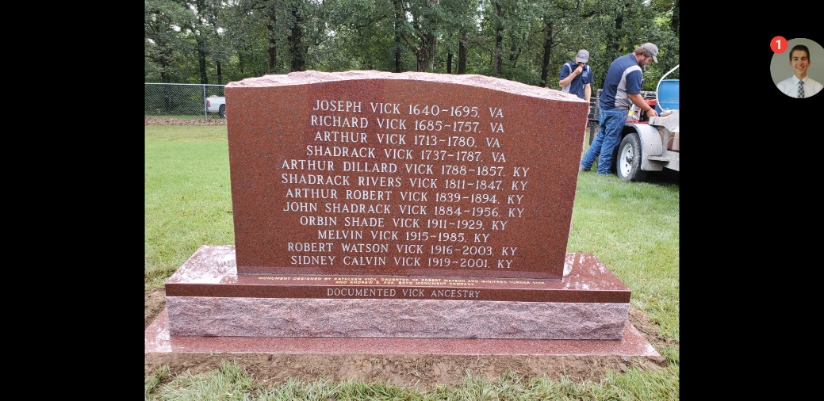
There is excepted also from the above about 17 acres sold by Marshall Rose to 1. T. Adcock by deed dated Dec 31, 1592, and recorded in Deed Book 19, Page 256 of the records of the Livingston County Court Clerk's Office.

This text goes with the matrix of the Vick Cemetery:
- Grave plot number 1 through 41- Are moratorium plots, to close to the fence
- Grave plot number 42 through 79- Are blank plots.
- Grave plot number 80 & 81- Are moratorium plots.
- 82 through 92- Are blank plots.
- 93 through 95- Are moratorium plots.
- 96 through 119- Are blank plots.
- 120 & 121- Are moratorium plots.
- 122 through 132- Are blank plots.
- 133- Is a moratorium plot.
- 134- Is an unknown marker.
- 135- Is a moratorium plot.
- 136 through 159- Are blank plots.
- 160 & 161- Are moratorium plots.
- 162 through 172- Are blank plots.
- 173 through 175- Are moratorium plots.
- 176 through 199- Are blank plots.
- 200 & 201- Are moratorium plots.
- 202 through 239- Are blank plots.
- 240 & 241- Are moratorium plots.
- 242 through 279- Are blank plots.
- 280 & 281- Are moratorium plots.
- 282 through 297- Are blank plots.
- 298 & 301- Are moratorium plots.
- 302 through 305- Are blank plots.
- 306 through 310- Are moratorium plots.
- 311 through 319- Are blank plots.
- 320 & 321- Are moratorium plots.
- 322 through 334- Are blank plots.
- 335 through 338- Are moratorium plots.
- 339 & 340- Are unknown markers.
- 341 through 346 - Are moratorium plots.
- 347- Is an unknown marker.
- 348- Mary E wife of J.J. Myrick, born Aug 30, 1659- died July 29, 1887.
- 349- J.J. Myrick, born 1352 - died 1906.
- 350- Is a moratorium plot
- 351 through 358- Are blank plots.
- 359 - Jeanette Quertermous
- 360 & 361- Are moratorium plots.
- 362 through 372- Are blank plots.
- 373 through 375- Are moratorium plots.
- 376 to 378 - Are unknown markers.
- 379 through 381- Are moratorium plots.
- 382- Nancy Vick, born Feb 2, 1796 - died Jan 12, 1852, age 55 years, 11 months and 10 days.
- 383- Arthur Vick, born Feb 12, 1788- died May 11, 1857
- 384- Nancy Haney.
- 385- Shadrack Vick.
- 386- Is an unknown marker.
- 387 through 390- Are moratorium plots.
- 391 through 392- Are blank plots.
- 393- Has been requested by Glenda Vick, she is still living in New Mexico.
- 394 through 399- Are blank plots.
- 400 & 401- Are moratorium plots.
- 402 through 412- Are blank plots.
- 413- Is a moratorium plot.
- 414- Is an unknown marker.
- 415 & 416- Are moratorium plots.
- 417- Is an unknown Marker.
- 418- Is a moratorium plot.
- 419 to 421 - Are unknown markers.
- 422- Alex R.C. Dixon, born Feb 28, 1815- died Apr 9, 1856.
- 423 to 425 - Are unknown markers.
- 426- U.B. Dixon, born May 11. 1854 - died Mar 2, 1885. Written on the marker “A loving husband a father dear, a faithful friend lies buried here”.
- 427 & 428 - Are unknown markers.
- 429 through 431- Are moratorium plots.
- 432 through 439- Are blank plots.
- 440 & 441- Are moratorium plots.
- 442 through 452- Are blank plots.
- 453- Is a moratorium plot.
- 454 to 458- Are unknown markers.
- 459- Mary M. Vick, born Dec 14, 1881 - died Dec 22, 1881. Daughter of J. and M.E. Vick. Written on the marker, “Lovely babe how brief thy stay, short and hasty was thy day” - There is also an unknown marker in this same plot.
- 460- Nancy A. Vick, born Mar 4. 1849 - died Mar 23, 1854. Daughter of A.D. & M.A. Vick. Written on the marker, “An after time well meet her”.
- 461 through 465 – Are unknown markers.
- 466- Lucy Swailes, born May 8, 1844- died Aug. 19, 1919.
- 467- Arthur Robert Vick, born Dec. 27, 1838- died Jan 3, 1894.
- 468 through 469- Are moratorium plots.
- 470- Is an unknown marker.
- 471- Is a moratorium plot
- 472 through 479- Are blank plots.
- 480 & 481- Are moratorium plots.
- 482 through 492- Are blank plots.
- 493- Melvin Vick, born May 9, 1915- died Dec. 1, 1985.
- 494 & 495- Are moratorium plots.
- 496- 1912 W.G. & Dephine Hurley, born Nov 22, ____ - died Dec. 4, ____.
- 497- Is a moratorium plot.
- 498- Anna M. wife of J.F. Vick, born Aug 25, 1662- died Jul 7, 1886. Written on the marker, “Alight from our household is gone, a voice we loved is stilled, a placer vacant in our heart that never can be filled”.
- 499- Infant Vick, born Mar 17, 1882. Written on the marker, "Of such is the Kingdom of Heaven”. Infant daughter of J.F. and A.M. Vick.
- 500 & 501- Are unknown markers.
- 502- There are two unknown markers in this plot.
- 503- Is an unknown marker.
- 504- There are two unknown markers in this plot.
- 505- Is a unknown marker
- 506 through 511- Are moratorium plots.
- 512 through 519- Are blank plots.
- 520 & 521- Are moratorium plots.
- 522 through 532- Are blank plots.
- 533- Louise Vick Thurston, born Oct 17, 1921 - Died May 17, 1978.
- 534- Is an unknown marker.
- 535 through 540- Are moratorium plots.
- 541- Is an unknown marker.
- 542- Charley, born Dec 23, 1865 - died Aug 7, 1866. Written on marker, “Sleep on Sweet babes and take thy rest, God called thee home he thought It best”. Sons of G.W. & M. Faulkner who is buried at the plot 542-543.
- 543- George W., born Feb 6. 1864- Died Oct 21, 1871. Written on marker, “Sleep on Sweet babes and take thy rest, God called thee home he thought it best”. Sons of 9W. & M. Faulkner. Some markers as 542.
- 544 & 545 - Are unknown markers.
- 546- Is a moratorium plot.
- 547 through 559- Are blank plots.
- 560 & 561- Are moratorium plots.
- 562 through 570- Are blank plots.
- 571- Johnathon Wesley P. Vick, infant, born & died April 15, 1969
- 572- Mary S. Vick. Daughter of Arthur Robert and Lucy
- 573- John Shadrack Vick, born Apr 28, 1884- died Sep 7, 1956. Written on marker, “Husband of Addie Radcliffe”.
- 574- Is a moratorium plot.
- 575- Is an unknown marker.
- 576 through 583- Are moratorium plots.
- 584- Elizabeth Tillery? born ___ 30, 1863 - died May ___, 1888.
- 585 & 586- Are moratorium plots.
- 587 through 559- Are blank plots.
- 600 & 601- Are moratorium plots.
- 602 through 608- Are blank plots.
- 609 – William Sidney Vick (Billy), born April 3, 1955, died October 15, 2014, Son of Sidney Calvin
- 610 - Lola May Cromwell, born Jul 21, 1918, died Mar 9, 2012 Wife of Sidney C. Vick. Daughter of Edward Vandemark and Laura Permalia Havenhill
- 611- Udell Vick, born Jun 16, 1946- died Sep 7, 1967. Written on marker, California AX3 US Navy
- 612- Orbin Shade Vick. Son of John Shadrack Vick who is buried at the plot 573.
- 613- Joseph H. Vick. Son of Arthur Robert and Lucy Vick
- 614 & 615 - Are unknown markers.
- 616 & 617- Are moratorium plots.
- 618- Is an unknown marker.
- 619 through 625- Are moratorium plots.
- 626 through 639- Are blank plots.
- 640 & 641- Are moratorium plots.
- 642 through 649- Are blank plots.
- 650- Jena Marie Vick, born Jul 24, 1973 - died Feb 22, 1981. Written on the marker, “Parents, Gailen Vick & Stella Hernandez. Grandparents, Sidney Vick & Lola Vandermark. Great Grandparents, John S. Vick & Addie Radcliffe and Edward Vandermark & Lura Havenhill.
- 651- Is a moratorium plot. Saved for Sidney C. Vick who is buried in McMurry Cemetery.
- 652- Susan Elizabeth Farley, born Mar 28, 1929 - died 1932. Written on the marker, "Daughter of W.S. & Lodie Farley”.
- 653- Is a moratorium plot.
- 654- Lizze Farley, born May 5, 1891 - diet Feb 14, 1911 Written on marker, “Daughter of W.S. & Callie Farley'. Same marker on plot 655 & 656.
- 655- Callie F. Chittenden, born Aug 18, 1855- died Jul 24, 1940. Same marker plots 654 & 656.
- 656- W.S. Farley, born Jan 14. 1869- Died Feb 7, 1892. Written on marker, “Daughter of W.S. & Callie Farley". Same marker plot as 654 & 655.
- 657- Is a moratorium plot.
- 658- There are two unknown markers in this plot.
- 659- Quertermous.
- 660- Lilly Bell Radcliffe, 1912.
- 661 through 663- Are moratorium plots.
- 664 through 679- Are blank plots.
- 680 & 681- Are moratorium plots.
- 682 through 693- Are blank plots.
- 694- Is a moratorium plot.
- 695 & 696- Are unknown markers.
- 697- Is a moratorium plot.
- 698- Is an unknown marker
- 699- Nancy Sension Rose, born Sep 4, 1846- died Dec 27, 1919. Written on the marker, “Come Ye Blessed”.
- 700- Marshall Rose, born Jan 17, 1840- died Mar 9, 1905.
- 701 & 702- Are unknown markers.
- 703- Is a moratorium plot.
- 704 through 719- Are blank plots.
- 720 & 721- Are moratorium plots.
- 722 through 734- Are blank plots.
- 735 through 743- Are moratorium plots.
- 744 through 745- Are blank plots.
- 746- Winifred T. Vick, born __ __,1920- Died 1991. Written on the marker, “Mother of Robert, Melvin, David, Sherrill, Kathleen, Wesley, Sally, Sheila, Nina, Henry and Glenda”.
- 747- Is a blank plot.
- 748 - Barbara Herndon Vick, Feb. 26, 1956-Nov. 9, 2010. Shared marker with plot 749.
- 749 - Marker for David Clifford Sr Vick, who is still living. Shared marker with plot 748.
- 750 through 759 - Are blank plots.
- 760 & 761- Are moratorium plots.
- 762 through 783 - Are blank plots.
- 784 - Marker for Sherrill E. Vick born Jun. 2, 1945 & Nancy L. Vick born Nov. 9, 1946, who are still living.
- 785 - Marker for Melvin Charles Vick born Mar. 14, 1941, died Nov. 6, 2007. Son John Shade & Marshall Clayton
- 786 - Marker for Robert Dewey Vick born Sept. 1 , 1939, died Feb. 12, 1996. Laid to rest in Damon, TX
- 787 through 792- Are blank plots.
- 793- Robert Watson Vick, born Oct 29, 1915- March 31, 2003. Written on the marker, “Father of Robert, Melvin, Demo, Sherrill, Kathleen, Wesley, Sally, Sheila, Nina, Henry and Glenda".
- 794 through 798- Are blank plots.
- 799 - Marker for Wesley Norman (Pete) Vick, born Sept. 4, 1948, died Aug. 13, 2013
- 800 through 840- Should not be used; it is too close to the entrance at the front gate & Fence.

As with all things that men attempt, there are mistakes made. So, with that thought, please send any corrections to: Gailen Vick, 2678 S. Wildflower Dr, Saratoga Springs, UT. 84045, phone 510-364-7631, and email is gailenvick@gmail.com

The Vick Cemetery is in Livingston County, Kentucky. About 6 miles out of Burna and through Hampton near Good Hope Church at the end of Quertermous Road.

References for the plot matrix and cemetery rules.
• If greater-than 50% of the grave boundaries fell within the grid, then the grave was given that grid's number.
• If greater-than 50% of the tombstone was inside the blot grid, then the grave was assumed to be m that designated plot number
For future graves
• If a tombstone marker is the 4 foot by 8-foot (32 square feet) boundaries touches any portion of a adjacent grave plot, then that plot or plots are considered in a moratorium.
• Whenever a grave is to be dug, a member of the Cemetery Committee must be on site in order to assure that no old grave sites without markers are disturbed. Any graves that are uncovered must be reported and all digging at that section must stop until the Cemetery Committee can determine who's grave it might be, and an appropriate marker placed.
• All future grave markers must lie at the most western section of the plot and no foot markers are allowed.
Cemetery Committee:
• Chairman - Kathleen Vick Moodie

• Vice Chairman - David Clifford Sr Vick

• Member – Shadwrick Joseph Vick

• Secretary - Gailen Vick, 441 W Main St, Suite D, Lehi, UT. 84043
Phone 801-331-8931 - gailenvick@gmail.com

Legend for Cemetery Matrix
 | Grass outside of Cemetery
# | Moratorium Plots
# | Unknown Marker
# | Reserved Plot
# | Known Marker
 | Open or blank plots
# | Marker needed

Typically, our family has employed Boyd Funeral Home in Salem, Ky to arrange burials and head stones.
Andrew Fox, Funeral Director – andy@boydfuneraldirectors.com, 270-988-3131 or mobile 270-969-0134
 | Vick Cemetery, Good Hope Bluff, Near Hampton, Kentucky
761 | 721 | 681 | 641 | 601 | 561 | 521 | 481 | 441 | 401 | 361 | 321 | 281 | 241 | 201 | 161 | 121 | 81
 |  |  |  |  |  |  |  |  |  | 359
 |  |  |  | 609
 |  |  | 650 | 610
 |  |  | 651 | 611 | 571
 |  |  | 652 | 612 | 572
 |  |  |  | 613 | 573 | 533 | 493
 |  |  | 654 | 614 | 574 | 534 |  | 454 | 414 |  |  |  |  |  | 134
 |  | 695 | 655 | 615 | 575 |  |  | 455
 |  | 696 | 656 |  |  |  | 496 | 456 |  | 376
 |  |  |  |  |  |  |  | 457 | 417 | 377
 |  | 698 | 658 | 618 |  |  | 498 | 458 |  | 378
 |  | 699 | 659 |  |  |  | 499 | 459 | 419 |  | 339
 |  | 700 | 660 |  |  |  | 500 | 460 | 420 |  | 340
 |  | 701 |  |  |  | 541 | 501 | 461 | 421
 |  | 702 |  |  |  | 542 | 502 | 462 | 422 | 382
 |  |  |  |  |  | 543 | 503 | 463 | 423 | 383
784 |  |  |  |  | 584 | 544 | 504 | 464 | 424 | 384
785 |  |  |  |  |  | 545 | 505 | 465 | 425 | 385
786 | 746 |  |  |  |  |  |  | 466 | 426 | 386
 |  |  |  |  |  |  |  | 467 | 427 |  | 347
 | 748 |  |  |  |  |  |  |  | 428 |  | 348
 | 749 |  |  |  |  |  |  |  |  |  | 349
 |  |  |  |  |  |  |  | 470
793 |  |  |  |  |  |  |  |  |  | 393
799
800 |  |  | 680 | 640 | 600 | 560 | 520 | 480 | 440 | 400 | 360 | 320 | 280 | 240 | 200 | 160 | 120
Fence Gate

